Human Resources: UHC Enroll + Terminate

**Objective/Purpose/ Why:** All full-time employees are eligible for benefits, the first of the month after DOH. Employee elections and terminations must be entered into the providers online web portal to establish the update.

**Outcome:**

* **Enrollment:** Coverage made effective. Upon entry into the provider’s online web portal, the employee and dependents will be active in the system and obtain Healthcare benefits.
* **Termination:** Cancelation of coverage. The employee has lost eligibility for Healthcare benefits and coverage will end on the last day of the month following the employees qualifying event.

**Subject Matter Expert:**

* To access the administrative functions through UnitedHealthcare, you must first have an Optum ID Login. Contact HR Director or HR Generalist(s)*.*

**Process:**

UHC: Employee Enroll/Add

1. Login to UHC

* Go to: employereservices.optum.com/ and click on Optum ID Login

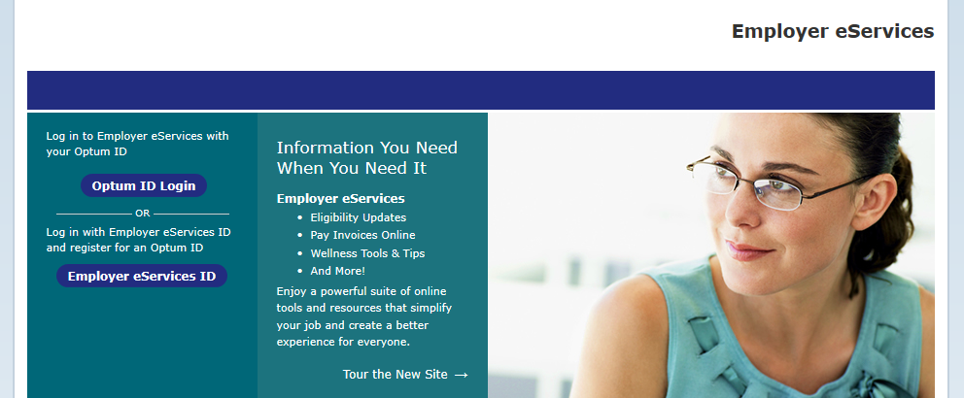

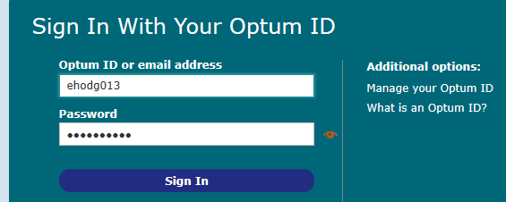

2. Add New Employee

* Click “Add New Employee” and select group.

Group 09F8585 BTEP is the “Free to Employee” Plan

Group 09F8595 BTD9 is the “Buy Up” Plan

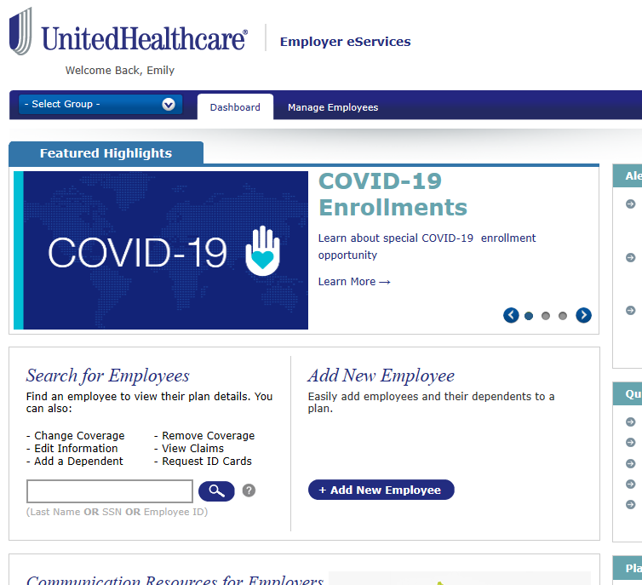

* Select Group:

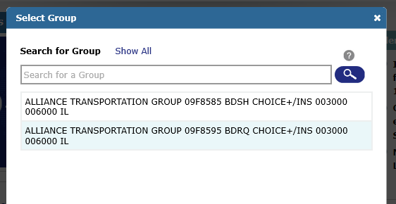

BTD9

BTEP

3. Enter Employee Information

* You must enter the effective date (first of the month after DOH) first, hit “Continue.”

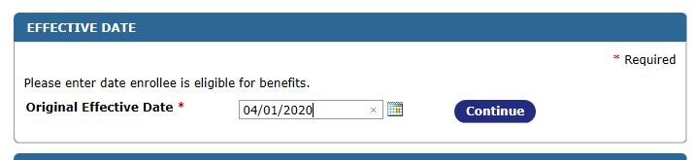

* Complete the Employee “DEMOGRAPHICS” section from the completed enrollment form:

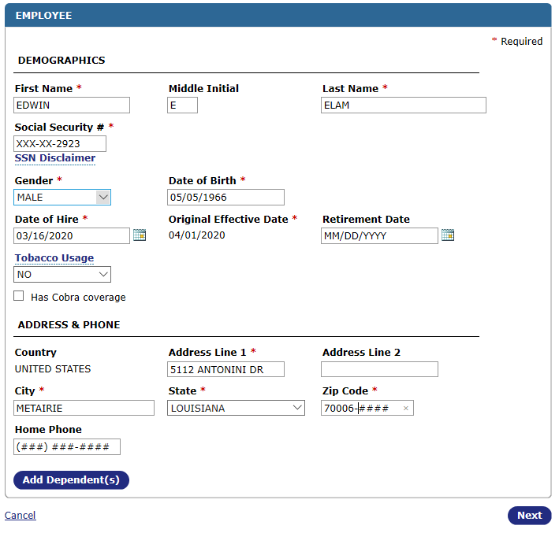

4. Add Dependents

* Add dependents, all pertinent information as listed on the enrollment form.
* Click “Next” when completed.

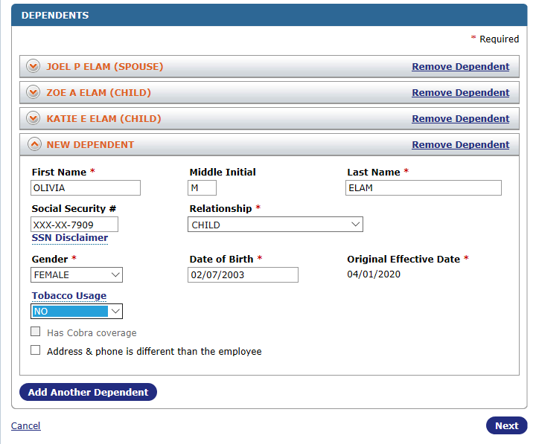

5. Select Medicare Coverage

* If the employee has not designated coverage, select “Unknown.” 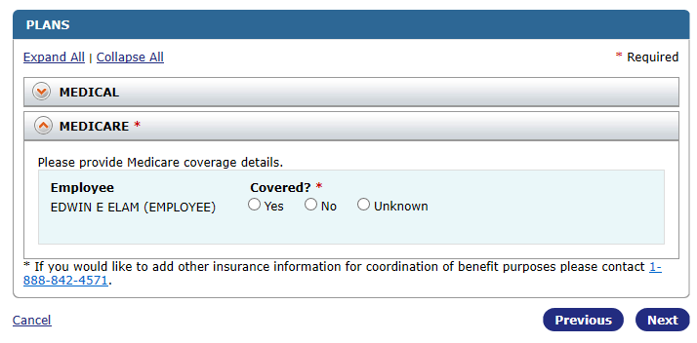

6. Select Medical Coverage.

* Use the information provided by employee on the enrollment form to select desired plan.
* Click “Apply Coverage to All” if appropriate, otherwise designate a desired plan for each dependent.
* Complete and click “Next” at the bottom

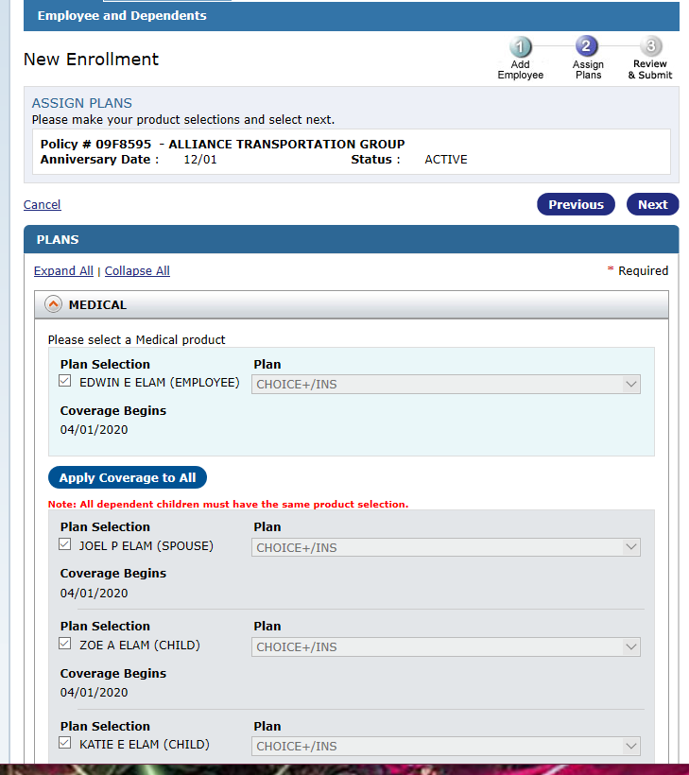

7. Review & Submit

* Enter annual salary and click “SUBMIT”.
* **Save confirmation.** Best practice is to select “View History”, print the confirmation page as PDF, and save to the benefits folder in their personnel file. (ie: Elam_E UHC OE)

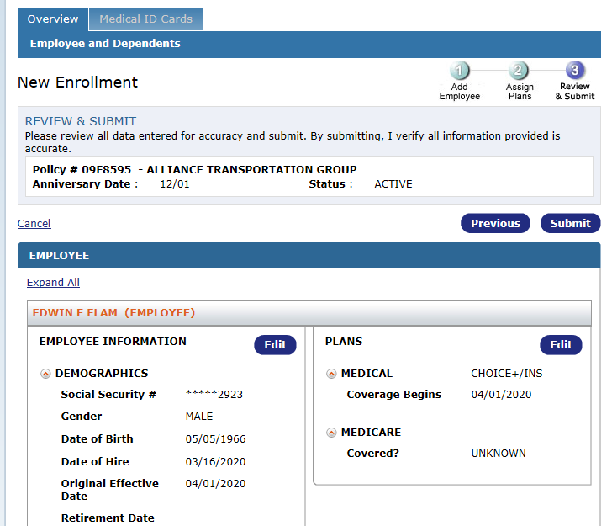

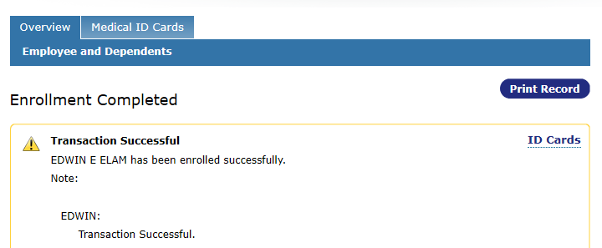

UHC: Employee Terminate

1. Login using Optum ID (same instructions as above)

2. Search for Employee

* Enter Last Name OR SSN OR Employee ID
* Select their elected coverage plan.
* Click on their hyperlinked name.

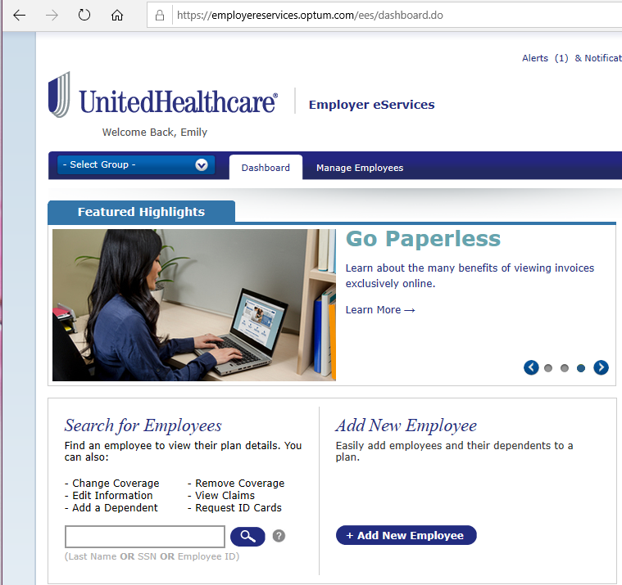

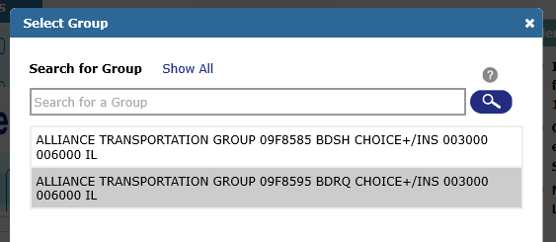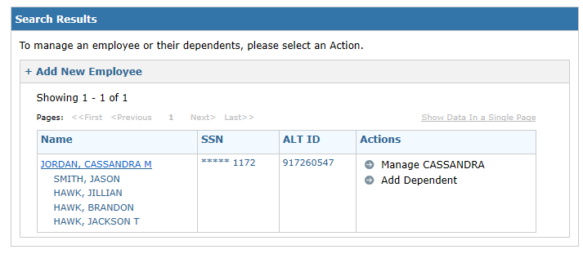

BTD9

BTEP

3. Finalize Termination

* Select “Terminate”

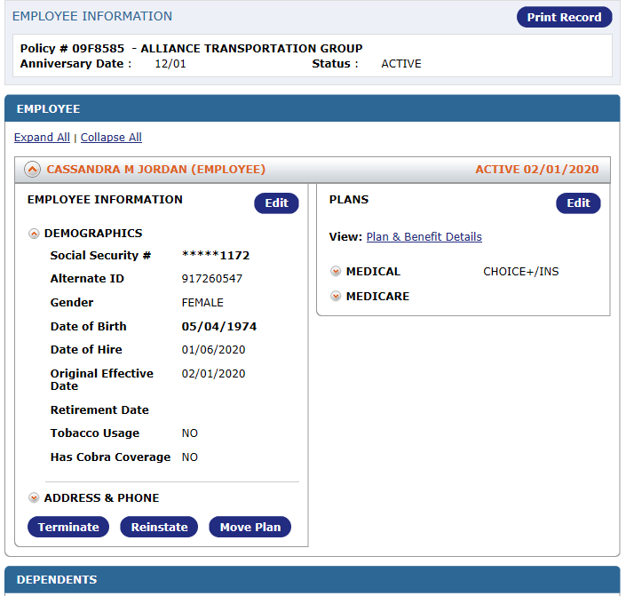

* Enter “Coverage End Reason” and “Coverage End Date”
* **Note:** Their “Coverage End Date” should be the first date employee will NOT have coverage (First of the month following date of termination).
* Select “Submit” at the bottom of the window when all is correct and verified.
* Print the confirmation page to PDF and save it to the benefits folder in their personnel file. (ie: Cassandra_ J UHC Term)

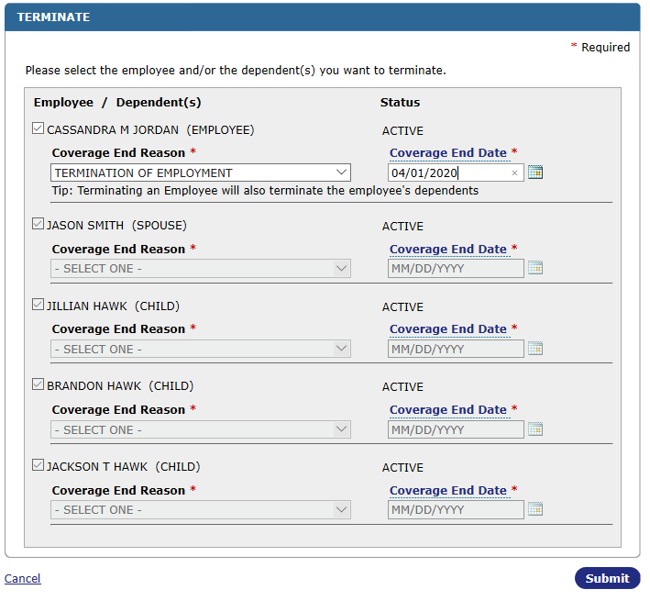

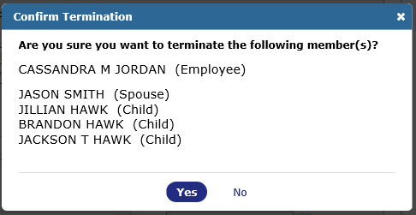

**Resources:**

* employereservices.optum.com/
* Open Enrollment forms are given to the employee when the employee becomes eligible for benefits or OE period from 11/01 - 11/31 plan year effective December 1- November 30
* A copy of the employees completed enrollment form should be saved to their benefits folder in their personnel file.
* A copy of the employees UHC Term should be saved to their Benefits folder in their personnel file.

**Definitions:**

* **UHC:** United Healthcare, ATG’s elected Health Benefits provider as of December 2020 for all full time employees.
* **Dependents:** Spouse, Children. etc.
* **Termination:** Cancelation of benefits coverage.
* **Coverage End Date:** should be the first date employee will NOT have coverage (first day of the month following date of termination).
* **OE:** Open Enrollment